A

SEMINAR REPORT

ON

THE PROJECT ENTITLED

**ACCIDENT AVOIDANCE SYSTEM USING DROWSINESS DETECTION BASED ON ML & IP**

SUBMITTED IN PARTIAL FULFILMENT OF THE REQUIREMENT FOR THE DEGREE OF

**BACHELOR OF ENGINEERING**

In

**ELECTRONICS AND TELECOMMUNICATION ENGINEERING**

By

**Sahil Ramteke**   **Exam. No:ETBA029**

**Shashikant Gujar**  **Exam. No:ETBA010**

**Sagar Deshbhratar** **Exam. No:ETBA005**

Under the Guidance of

**Prof. J. P. Shinde**



**Sinhgad Institutes**

Submitted to

**DEPARTMENT OF ELECTRONICS AND TELECOMMUNICATION ENGINEERING**

**STES’S SINHGAD ACADEMY OF ENGINEERING, PUNE-411048**

**2021-2022**

**CERTIFICATE**

This is to certify that the seminar report entitled

**ACCIDENT AVOIDANCE SYSTEM USING DROWSINESS DETECTION**

**BASED ON ML & IP**

Submitted By

Is a bonafide work carried out by them under the supervision by Prof. J. P. Shinde and it is approved for the partial fulfilment of the requirement of **Savitribai Phule Pune University** for the Project Part–I in the Final Year of Electronics and Telecommunication Engineering.

This Seminar report has not been earlier submitted to any other institute or University for the award of any degree or diploma.

|  |  |  |
| --- | --- | --- |
| **Prof. J. P. Shinde**  **Guide** | **Dr. K.M. Gaikwad**  **H.O.D and Vice Principal** | **Dr. Kishore P. Patil**  **Principal, SAOE, Pune** |
| Place: Pune |  |  |
| Date: |  |  |

**ACKNOWLEDGEMENT**

First and foremost, I would like to thank our guide Prof. J. P. Shinde who guided us in doing these project.She provided us with invaluable advice and helped us in difficult periods. Her motivation and help contributed tremendously to the successful completion of the project.

Besides, we would like to thank all the teachers who helped us by giving us advice and providing the equipment which we needed.

Also I would like to thank my department for their support. Without that support we couldn’t have succeeded in completing this project.

At last but not in least, we would like to thank everyone who helped and motivated us to work on this project.

**Project Group Members:**

**Sahil Ramteke**  **Exam. No:ETBA029**

**Shashikant Gujar**  **Exam. No: ETBA010**

**Sagar Deshbhratar** **Exam. No: ETBA005**

**ABSTRACT**

Drowsy Driver Detection System has been developed using a non-intrusive machine vision based concepts. The system uses a small monochrome security camera that points directly towards the driver’s face and monitors the driver’s eyes in order to detect fatigue. In such a case when fatigue is detected, a warning signal is issued to alert the driver. This report describes how to find the eyes, and also how to determine if the eyes are open or closed. The algorithm developed is unique to any currently published papers, which was a primary objective of the project. The system deals with using information obtained for the binary version of the image to find the edges of the face, which narrows the area of where the eyes may exist. Once the face area is found, the eyes are found by computing the horizontal averages in the area. Taking into account the knowledge that eye regions in the face present great intensity changes, the eyes are located by finding the significant intensity changes in the face. The areas of the left and right side are compared to check whether the eyes are found correctly. Calculating the left side means taking the averages from the left edge to the centre of the face, and similarly for the right side of the face. The reason for doing the two sides separately is because when the driver’s head is tilted the horizontal averages are not accurate. For example if the head is tilted to the right, the horizontal average of the eyebrow area will be of the left eyebrow, and possibly the right hand side of the forehead.

**Table of Contents**

|  |  |  |  |
| --- | --- | --- | --- |
| Acknowledgement | | | v |
| Abstract | | | vii |
| Table of Contents | | | viii |
|  | | |  |
| **Chapter 1** | **Introduction** | | x |
| 1.1 | Prelude | | x |
| 1.2 | Motivation | | xi |
| 1.3 | Objectives of the proposed work | | xi |
|  |  | |  |
| **Chapter 2** | **Literature Review** | | xiii |
|  |  | |  |
| **Chapter 3** | **Design & Working** | | xv |
| 3.1 | Block Diagram | | xv |
| 3.2 | Project Requirement | | xv |
| 3.3 | Working | | xviii |
| 3.4 | Algorithm | | xviii |
| 3.5 | Methodology | | xix |
|  |  | |  |
| **Chapter 4** | **Codes** | | |
| 4.1 | Code | xix | |
|  |  |  | |
| **Chapter**  **5** | **Future Development** | xxv | |
| 5.1 | Advantages | xxv | |
| 5.2 | Application | xxvi | |
| 5.3 | Future Scope | xxvi | |
| 5.4 | Conclusion | xxvi | |
| 5.5 | Refrences | xxviii | |
|  | | | |

|  |  |  |
| --- | --- | --- |
|  |  |  |
|  |  |  |
|  |  |  |
|  |  |  |
|  |  |  |
|  |  |  |
|  |  |  |
|  |  |  |
|  |  |  |
|  |  |  |
|  |  |  |
|  |  |  |
|  |  |  |
|  |  |  |
|  |  |  |

|  |  |  |
| --- | --- | --- |
|  |  |  |
|  |  |  |
|  |  |  |
|  |  |  |
|  |  |  |
|  |  |  |
|  |  |  |
|  |  |  |
|  |  |  |
|  |  |  |
|  |  |  |
|  |  |  |
|  |  |  |
|  |  |  |
|  |  |  |

**CHAPTER 1**

**INTRODUCTION**

**1.1 PRELUDE**

Automotive population is increasing exponentially in our country. The Biggest problem regarding the increased use of vehicles is the rising number of road accidents. Road accidents are undoubtedly a global menace in our country. The frequency of road accidents in India is among the highest in the world. According to the reports of the National Crime Records Bureau (NCRB) about 135,000 road accidents-related deaths occur every year in India. The Global Status Report on Road Safety published by the World Health Organization (WHO) identified the major causes of road accidents are due errors and carelessness of the driver.Driver drowsiness, alcoholism and carelessness are the key contributions in the accident scenario.

Drowsiness is simply defined as “a state of near sleep due to fatigue”. It is technically distinct from fatigue, which has been defined as a “disinclination to continue performing the task at hand”. The effects of sleepiness and fatigue are very much the same. Fatigue affects mental alertness, decreasing an individual’s ability to operate a vehicle safely and increasing the risk of human error that could lead to fatalities and injuries. Sleepiness slows reaction time, decreases awareness, and impairs judgment. Fatigue and sleep deprivation impact all transportation operators (for example: airline pilots, truck drivers, and railroad engineers).In both conditions, driver can’t focus on primary task of driving which may enhance the likelihood of crash occurrence.

**1.2 MOTIVATION**

With the ever-growing traffic conditions, this problem will further deteriorate. For this reason, it is necessary to develop driver alertness system for accident prevention due to Driver Drowsiness as shown in Fig.1. Interaction between driver and vehicle such as monitoring and supporting each other is one of the important solutions for keeping ourselves safe in the vehicles. Although active safety systems in vehicles have contributed to the decrease in the number of deaths occurring in traffic accidents, the number of traffic accidents is still increasing. Fig.1

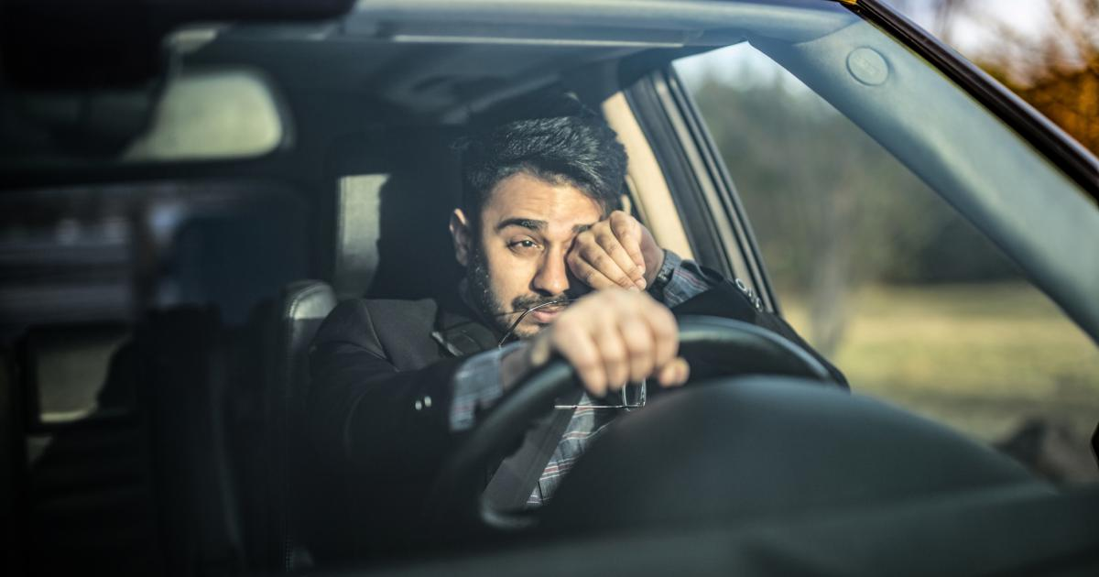 Fig.1

Example of Driver Drowsiness The National Highway Traffic Safety Administration (NHTSA) estimates that approximately 100,000 crashes each year are caused primarily by driver drowsiness or fatigue. Indian government also passed a law named ‘Motor Bill’ to improve safety on roads caused by driver drowsiness. The Bill is aimed at bringing down fatalities in road accidents by two lakh in the first five years in a scenario where India reports around 5lakh road accidents annually.

**1.3 OBJECTIVES OF PROPOSED WORK**

One solution to this serious problem is the development of an intelligent vehicle that can predict driver drowsiness and prevent drowsy driving. The percentage of eyelid closure over the pupil over time (PERCLOS) is one of the major methods for the detection of the driver’s drowsiness. Physiological measurements like electroencephalogram (EEG), electrocardiogram (ECG), capturing eye closure, facial features, or driving performance (such as steering characteristics, lane departure, etc.)are used for drowsiness detection. When drowsiness is detected while driving audible sound,vibrations or warning messages on a display are generally used to warn the driver to concentrate on driving or to take a rest. These methods help the drowsy driver to prevent drowsiness-related crashes in a moment, but it is hard to get rid of drowsiness by just being aware of it.Most of the methods which rely on camera input for detection of opening and closing eyelids are not to be tested like they can be implemented in real time as most of the scholars take image as camera is fixed in front of the driver’s road view. As for clear view, it is not possible to put the camera on front mirror. Secondly most of papers have drawbacks when there is high luminance caused by sunlight as well as during dim light conditions like bad weathers

**CHAPTER 2**

**LITERATURE REVIEW**

**1]In 2008, Hong Su et. al. [15] described ‘A Partial Least Squares Regression-Based Fusion Model for Predicting the Trend in Drowsiness’.**

They proposed a new technique of modeling driver drowsiness with multiple eyelid movement features based on an information fusion technique—partial least squares regression (PLSR), with which to cope with the problem of strong collinear relations among eyelid movement features and, thus, predicting the tendency of the drowsiness. The predictive precision and robustness of the model thus established are validated, which show that it provides a novel way of fusing multi-features together for enhancing our capability of detecting and predicting the state of drowsiness.

**2]In June, 2010, Bin Yang et. al. [16] described ‘Camerabased Drowsiness Reference for Driver State Classification under Real Driving Conditions’**.

They proposed that measures of the driver’s eyes are capable to detect drowsiness under simulator or experiment conditions. The performance of the latest eye tracking based in-vehicle fatigue prediction measures are evaluated. These measures are assessed statistically and by a classification method based on a large dataset of 90 hours of real road drives. The results show that eye-tracking drowsiness detection works well for some drivers as long as the blinks detection works properly. Even with some proposed improvements, however, there are still problems with bad light conditions and for persons wearing glasses. As a summary, the camera based sleepiness measures provide a valuable contribution for a drowsiness reference, but are not reliable enough to be the only reference.

**In 2011, M.J. Flores et. al. [17] described ‘Driver drowsiness detection system under infrared illumination for an intelligent vehicle’.** They proposed that to reduce the amount of such fatalities, a module for an advanced driver assistance system, which caters for automatic driver drowsiness detection and also driver distraction, is presented. Artificial intelligence algorithms are used to process the visual information in order to locate, track and analyze both the driver’s face and eyes to compute the drowsiness and distraction indexes. This realtime system works during nocturnal conditions as a result of a near-infrared lighting system. Finally, examples of different driver images taken in a real vehicle at nighttime are shown to validate the proposed algorithms.

**3]In June, 2012, A. Cheng et. al. [18] described 'Driver Drowsiness Recognition Based on Computer Vision Technology’**.

They presented a nonintrusive drowsiness recognition method using eye-tracking and image processing. A robust eye detection algorithm is introduced to address the problems caused by changes in illumination and driver posture. Six measures are calculated with percentage of eyelid closure, maximum closure duration, blink frequency, average opening level of the eyes,

opening velocity of the eyes, and closing velocity of the eyes. These measures are combined using Fisher’s linear discriminated functions using a stepwise method to reduce the correlations and extract an independent index. Results with six participants in driving simulator experiments demonstrate the feasibility of this video-based drowsiness recognition method that provided 86% accuracy.

**In 2013, G. Kong et. al. [19] described ‘Visual Analysis of Eye State and Head Pose for Driver Alertness Monitoring’.** They presented visual analysis of eye state and head pose (HP) for continuous monitoring of alertness of a vehicle driver. Most existing approaches to visual detection of non-alert driving patterns rely either on eye closure or head nodding angles to determine the driver drowsiness or distraction level. The proposed scheme uses visual features such as eye index (EI), pupil activity (PA), and HP to extract critical information on non-alertness of a vehicle driver. A support vector machine (SVM) classifies a sequence of video segments into alert or non-alert driving events. Experimental results show that the proposed scheme offers high classification accuracy with acceptably low errors and false alarms for people of various ethnicity and gender in real road driving conditions.

**4]In August 2014, García et. al. [21] described ‘Driver Monitoring Based on Low-Cost 3-D Sensors’**.

They proposed a solution for driver monitoring and event detection based on 3-D information from a range camera is presented. The system combines 2-D and 3-D techniques to provide head pose estimation and regions-of-interest identification. Based on the captured cloud of 3-D points from the sensor and analyzing the 2-D projection, the points corresponding to the head are determined and extracted for further analysis. Later, head pose estimation with three degrees of freedom (Euler angles) is estimated based on the iterative closest points algorithm. Finally, relevant regions of the face are identified and used for further analysis, e.g., event detection and behavior analysis. The resulting application is a 3-D driver monitoring system based on low-cost sensors. It represents an interesting tool for human factor research studies, allowing automatic study of specific factors and the detection of special event related to the driver, e.g., driver drowsiness, inattention, or head pose After the conversion, L, a , b are all belong to [0,128] ， so we can use cluster method to classify the colors in the yarn-dyed fabric with Lab color space. The results shows of a figure after Lab Color Space operation

**In June, 2014, Eyosiyas et. al. [20] described ‘Driver Drowsiness Detection through \HMM based Dynamic Modeling’.** They proposed a new method of analyzing the facial expression of the driver through Hidden Markov Model (HMM) based dynamic modeling to detect drowsiness. They have implemented the algorithm using a simulated driving setup. Experimental results verified the effectiveness of the proposed method.

**CHAPTER 3**

**DESIGN & WORKING**

**3.1 BLOCK DIAGRAM**

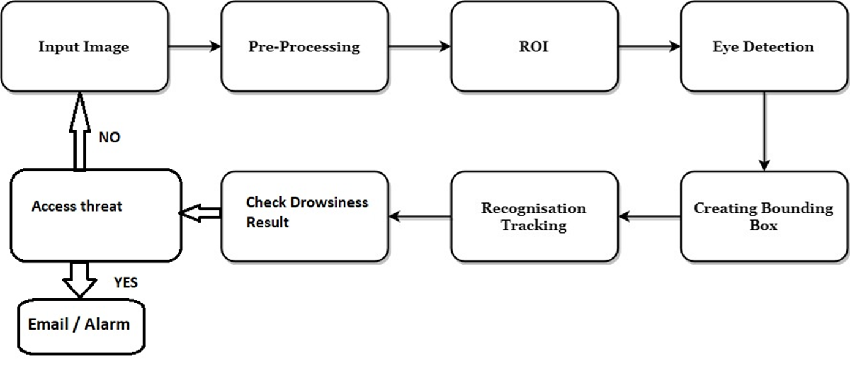

**3.2 PROJECT REQUIREMENT**

* **WEBCAM**

A webcam is a video camera that feeds or streams an image or video in real time to or through a computer network, such as the Internet. Webcams are typically small cameras that sit on a desk, attach to a user's monitor, or are built into the hardware. Webcams can be used during a video chat session involving two or more people, with conversations that include live audio and video.

Webcam software enables users to record a video or stream the video on the Internet. As video streaming over the Internet requires much bandwidth, such streams usually use compressed formats. The maximum resolution of a webcam is also lower than most handheld video cameras, as higher resolutions would be reduced during transmission. The lower resolution enables webcams to be relatively inexpensive compared to most video cameras, but the effect is adequate for video chat sessions.

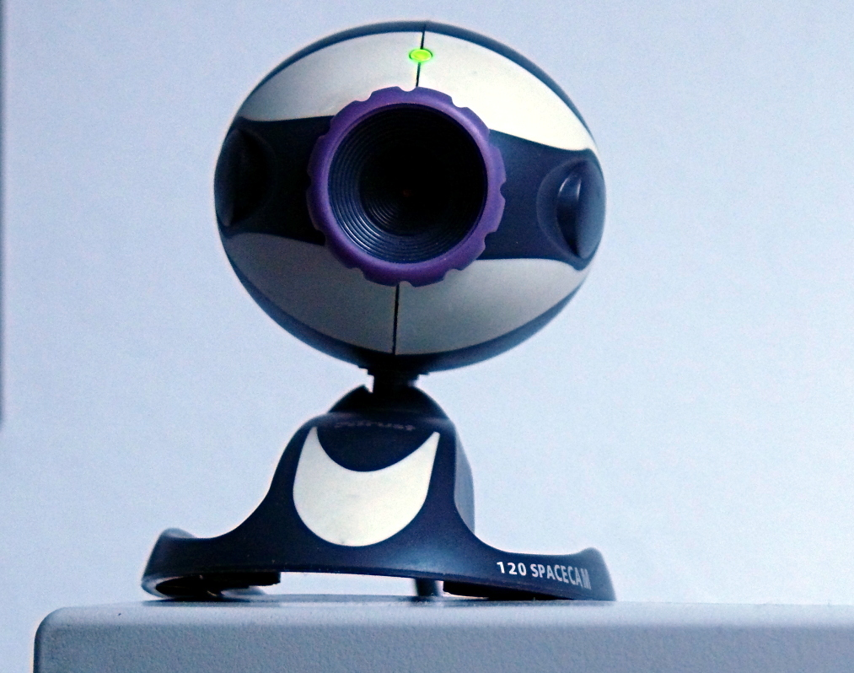

* **PYTHON**

1. OpenCV – (face and eye detection).
2. TensorFlow – (keras uses tensorflow as backend).
3. Keras – (to build our classification model).
4. Pygame – (to alarm sound).
5. SMS Python Quickstart –(with just few lines of code,your python application can send alert sms messages with programmable messaging).



**3.3 WORKING**

In this Python project, we will be using OpenCV for gathering the images from webcam and feed them into a Deep Learning model which will classify whether the person’s eyes are ‘Open’ or ‘Closed’.

There are several different algorithms and methods for eye tracking, and monitoring. Most of them in some way relate to features of the eye (typically reflections from the eye) within a video image of the driver. The original aim of this project was to use the retinal reflection as a means to finding the eyes on the face, and then using the absence of this reflection as a way of detecting when the eyes are closed. Applying this algorithm on consecutive video frames may aid in the calculation of eye closure period. Eye closure period for drowsy drivers are longer than normal blinking. It is also very little longer time could result in severe crash. So we will warn the driver as soon as closed eye is detected.

**3.4 ALGORITHM**

1. New Image
2. Adjust brightness & contrast
3. Face detection
4. Eye detection
5. Extract eye region
6. Eye feature extraction
7. Determine close or open eye
8. Calculation of Drowsiness
9. Drowsy Driver
10. Alarm

**3.5 METHODOLOGY**

* The new image is been input and is detected for the face detection.
* The image brightness and contrast ratios are adjusted for the detection of face
* the later it undergoes the face detection if it is detected
* then it undergoes eye detection then the frame is adjusted around the eye region the eye region is extracted.
* The patterns are then processing for the eye blinking, whether the eyes are open or closed during the driving of the car.
* Then the data has been for the calculation of the drowsiness that the driver possess with the help of the fuzzy logic.
* If the driver is drowsy then the alarm signal is set on to make the driver alert that he is undergoing drowsiness state and the driver needs to stop driving or needs precautionary measure before the driving of the car.
* The first part is the eye detection function and the other is the Drowsiness Calculation function.

**CHAPTER 4**

**4.1 CODE**

from scipy.spatial import distance as dist

from imutils.video import VideoStream

from imutils import face_utils

from threading import Thread

import numpy as np

import pyglet

import argparse

import imutils

import time

import dlib

import cv2

def eye_aspect_ratio(eye):

# compute the euclidean distances between the two sets of

# vertical eye landmarks (x, y)-coordinates

A = dist.euclidean(eye[1], eye[5])

B = dist.euclidean(eye[2], eye[4])

# compute the euclidean distance between the horizon

# eye landmark (x, y)-coordinates

C = dist.euclidean(eye[0], eye[3])

# compute the eye aspect ratio

ear = (A + B) / (2.0 * C)

# return the eye aspect ratio

return ear

# construct the argument parse and parse the arguments

ap = argparse.ArgumentParser()

ap.add_argument("-w", "--webcam", type=int, default=0,

help="index of webcam on system")

args = vars(ap.parse_args())

# define two constants, one for the eye aspect ratio to indicate

# blink and then a second constant for the number of consecutive

# frames the eye must be below the threshold for to set off the

# alarm

EYE_AR_THRESH = 0.3

EYE_AR_CONSEC_FRAMES = 48

# initialize the frame counter as well as a boolean used to

# indicate if the alarm is going off

COUNTER = 0

ALARM_ON = False

# initialize dlib's face detector (HOG-based) and then create

# the facial landmark predictor

print("[INFO] loading facial landmark predictor...")

detector = dlib.get_frontal_face_detector()

predictor = dlib.shape_predictor("shape_predictor_68_face_landmarks.dat")

# grab the indexes of the facial landmarks for the left and

# right eye, respectively

(lStart, lEnd) = face_utils.FACIAL_LANDMARKS_IDXS["left_eye"]

(rStart, rEnd) = face_utils.FACIAL_LANDMARKS_IDXS["right_eye"]

# start the video stream thread

print("[INFO] starting video stream thread...")

vs = VideoStream(src=args["webcam"]).start()

time.sleep(1.0)

# loop over frames from the video stream

while True:

# grab the frame from the threaded video file stream, resize

# it, and convert it to grayscale

# channels)

frame = vs.read()

frame = imutils.resize(frame, width=450)

gray = cv2.cvtColor(frame, cv2.COLOR_BGR2GRAY)

# detect faces in the grayscale frame

rects = detector(gray, 0)

# loop over the face detections

for rect in rects:

# determine the facial landmarks for the face region, then

# convert the facial landmark (x, y)-coordinates to a NumPy

# array

shape = predictor(gray, rect)

shape = face_utils.shape_to_np(shape)

# extract the left and right eye coordinates, then use the

# coordinates to compute the eye aspect ratio for both eyes

leftEye = shape[lStart:lEnd]

rightEye = shape[rStart:rEnd]

leftEAR = eye_aspect_ratio(leftEye)

rightEAR = eye_aspect_ratio(rightEye)

# average the eye aspect ratio together for both eyes

ear = (leftEAR + rightEAR) / 2.0

# compute the convex hull for the left and right eye, then

# visualize each of the eyes

leftEyeHull = cv2.convexHull(leftEye)

rightEyeHull = cv2.convexHull(rightEye)

cv2.drawContours(frame, [leftEyeHull], -1, (0, 255, 0), 1)

cv2.drawContours(frame, [rightEyeHull], -1, (0, 255, 0), 1)

# check to see if the eye aspect ratio is below the blink

# threshold, and if so, increment the blink frame counter

if ear < EYE_AR_THRESH:

COUNTER += 1

# if the eyes were closed for a sufficient number of

# then sound the alarm

if COUNTER >= EYE_AR_CONSEC_FRAMES:

# if the alarm is not on, turn it on

if not ALARM_ON:

ALARM_ON = True

# check to see if an alarm file was supplied,

# and if so, start a thread to have the alarm

# sound played in the background

# draw an alarm on the frame

cv2.putText(frame, "DROWSINESS ALERT!", (10, 30),

cv2.FONT_HERSHEY_SIMPLEX, 0.7, (0, 0, 255), 2)

# otherwise, the eye aspect ratio is not below the blink

# threshold, so reset the counter and alarm

else:

COUNTER = 0

ALARM_ON = False

# draw the computed eye aspect ratio on the frame to help

# with debugging and setting the correct eye aspect ratio

# thresholds and frame counters

cv2.putText(frame, "EAR: {:.2f}".format(ear), (300, 30),

cv2.FONT_HERSHEY_SIMPLEX, 0.7, (0, 0, 255), 2)

# show the frame

cv2.imshow("Frame", frame)

key = cv2.waitKey(1) & 0xFF

# if the `q` key was pressed, break from the loop

if key == ord("q"):

break

# do a bit of cleanup

cv2.destroyAllWindows()

vs.stop()

**CHAPTER 5**

**FUTURE DEVELOPMENT**

**5.1 ADVANTAGES**

* The detected abnormal behavior is corrected through alarms in real time.
* Component establishes interface with other drivers very easily.
* Life of the driver can be saved by alerting him using the alarm system.
* Speed of the vehicle can be controlled.
* Traffic management can be maintained by reducing accidents.
* Region of interest is clear to identify
* Bounding box creation and tracking
* Practically applicable

**5.2 APPLICATION**

* Real time tracking applications
* If found drowsy, the alarm system gets activated and the driver is alerted.
* If there is any obstacles it is alerted to the driver
* This system can also be used for railway drivers.

**5.3 FUTURE SCOPE**

The future works may focus on the utilization of outer factors such as vehicle states, sleeping hours, weather conditions, mechanical data, etc. for fatigue measurement. Driver drowsiness poses a major problem to highway safety. 24 hours operations, high annual mileage, exposure to the challenging environmental condition, and demanding work schedules all contribute to the serious safety issue. Monitoring the driver’s state of drowsiness and vigilance and providing feedback on their condition so that they can take appropriate action is one crucial step in a series of preventive measure to necessary to address this problem. Currently there is no adjustment in zoom or direction of the camera during operation. Future work may be automatically zoom in on eyes once they are localized. This would avoid trade-off between having wide field of view in order to locate the eyes, and narrow view in order to detect fatigue

**5.4 CONCLUSION**

The driver abnormality monitoring system developed is capable of detecting drowsiness, drunken and reckless behaviors of driver in a short time.

The Drowsiness Detection System developed based on eye closure of the driver can differentiate normal eye blink and drowsiness and detect the drowsiness while driving.

The proposed system can prevent the accidents due to the sleepiness while driving.

Information about the head and eyes position is obtained through various self-developed image processing algorithms.

During the monitoring, the system is able to decide if the eyes are opened or closed.

When the eyes have been closed for too long, a warning signal is issued. Processing judges the driver’s alertness level on the basis of continuous eye closures.

**5.5 REFRENCES**

[1] Miaou, “Study of Vehicle Scrap page Rates,” Oak Ridge National Laboratory, Oak Ridge, TN,, S.P.,April 2012.

[2] Wreggit, S. S., Kim, C. L., and Wierwille, W. W., Fourth Semi-Annual Research Report”, Research on Vehicle-Based Driver Status Performance Monitoring”, Blacksburg, VA: Virginia Polytechnic Institute and State University, ISE Department, January 2013.

[3] Bill Fleming, “New Automotive Electronics Technologies”, International Conference on Pattern Recognition, pp. 484- 488,December 2012.

[4] Ann Williamson and Tim Chamberlain,“Review of on-road driver fatigue monitoring devices”, NSW Injury Risk Management Research Centre, University of New South Wales, , July 2013.

[5] E. Rogado, J.L. García, R. Barea, L.M. Bergasa, Member IEEE and E. López, February, 2013, “Driver Fatigue Detection System”, Proceedings of the IEEE International Conference on Robotics and Biometics, Bangkok, Thailand.

[6] Boon-Giin Lee and Wan-Young Chung, Member IEEE, “Driver Alertness Monitoring Using Fusion of Facial Features and Bio-Signals”, IEEE Sensors Journal, VOL. 12, NO. 7, July 2012.

[7] H. Singh, J. S. Bhatia, and J. Kaur, “Eye tracking based driver fatigue monitoring and warning system”, in Proc. IEEE IICPE, New Delhi, India, Jan. 2014

.